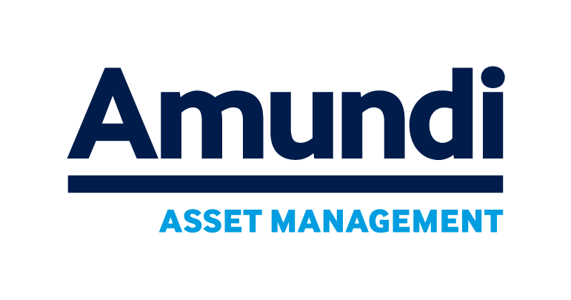

Press release

London, 28 January 2019

Appointments

Pascal Duval is appointed Head of Retail Solutions. He is a member of the Executive Committee

Julien Fontaine is appointed Head of Partnerships. He is member of Executive Committee

°
° °

Pascal Duval, Head of Retail Solutions
Pascal worked for Russell Investments in EMEA for 22 years, during which he developed the asset manager’s Continental European and Middle-East business and the opening of the Paris office. He was appointed CEO for EMEA in 2011 and became a member of Russell Investment’s Global Executive Committee. Pascal left Russell Investments in January 2017 and founded Duval Capital LLP, a research and advisory company in wealth and asset management. During the same year he was appointed Chairman of the Voluntary Solidarity Fund International upon its incorporation as a registered Charity in England and Chairman of the Aberdeen Standard Logistics European Income Trust plc.

Pascal started his career as a commodity and FX trader in Paris (Riz & Denrees, 1985), and then as a consultant in investment and management for corporates, institutional investors, asset managers, banks and insurance companies.

Pascal holds a BA in Law from Paris X University, is a graduate of the Institut d’Etudes Politiques de Paris and INSEAD.

Julien Fontaine, Head of Partnerships
Julien began his career in 1999 at the French Ministry of Foreign Affairs as an advisor. In 2000, he joined McKinsey & Company and, in 2009, became a Partner in charge of financial services. In September 2011, Julien joined Crédit Agricole S.A. as Head of Group Strategy before becoming CEO of Amundi Japan in 2014. He subsequently became Head of Retail Marketing for the Amundi Group in January 2018.

Julien is a graduate of the Institut d'Etudes Politiques de Paris and ESSEC, and a graduate of the Ecole Nationale d'Administration.

About Amundi

Amundi is Europe’s largest asset manager by assets under management and ranks in the top 10 globally. It manages more than 1.47 trillion euros of assets across six main investment hubs. Amundi offers its clients in Europe, Asia-Pacific, the Middle-East and the Americas a wealth of market expertise and a full range of capabilities across the active, passive and real assets investment universes. Headquartered in Paris, and listed since November 2015, Amundi is the 1st asset manager in Europe by market capitalization.

Leveraging the benefits of its increased scope and size, Amundi has the ability to offer new and enhanced services and tools to its clients. Thanks to its unique research capabilities and the skills of close to 4,500 team members and market experts based in 37 countries, Amundi provides retail, institutional and corporate clients with innovative investment strategies and solutions tailored to their needs, targeted outcomes and risk profiles.

Amundi. Confidence must be earned.

Visit www.amundi.com for more information or to find the Amundi team closest to you.

Follow us on   

Press Contact

Amundi
Fany de Villeneuve
Tel: +44 (0)20 7190 2040
Fany.devilleneuve@amundi.com
Maitland
Jais Mehaji
T: +44 20 7379 5151
jmcfarlane@maitland.co.uk

Source IPE “Top 400 asset managers” published in June 2018 and based on AUM as of end December 2017.
Amundi figures as of September 30 2018
Investment hubs: Boston, Dublin, London, Milan, Paris and Tokyo
Based on market capitalization as of September 30, 2018

